# Advance Care Planning (ACP)

The **Advance Care Planning (ACP)** score is modeled after the Personal Severity Index (PSI) and is based on a predictive score calculated using either clinical data from the EHR on new residents or MDS 3.0 items once a MDS assessment is complete. **A score of 9 or greater** helps providers identify residents who may be moving towards end of life and who may require changes to their current care plans and Advance Directives. This information allows providers to initiate discussions with a resident and/or family, including a review of Code status and end-of life decisions.

## ACP Alerts and Tagging locations in Real Time

1. **Alerts by Category**

* ACP Alerts will show as an alert in the Clinical Alerts by Category/24 Hour Report for 3 days for residents triggering a score of 9 or greater on the PSI.
* By clicking this portion of the pie chart for ACP, you may view the alerts for newly triggered residents.
* The alert will include the residents ACP Score as well as the date it was first triggered.

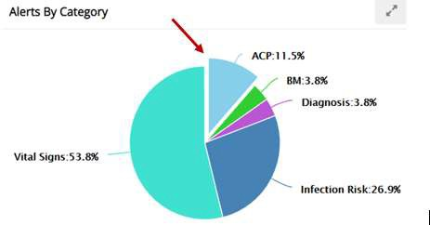 Best Practice: Review on Mondays to catch any residents that may have triggered over the weekend (72hrs).

1. **ACP Tagging**

* An icon will follow the patient’s name throughout Real Time if the patient’s current score is 9 or greater.

ACP

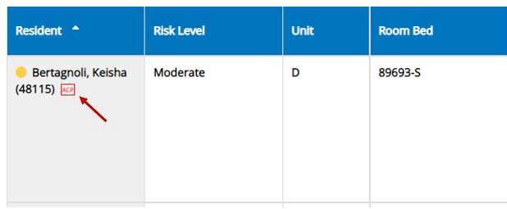

1. **Advance Care Planning (ACP) Score Report**

* Found in the reports tab on the Main Menu>Clinical Reports.
* Report of all residents in the facility who have a score of 9 or greater.
* By clicking the + to the left of the resident’s name, the details of the ACP score will be displayed below.
* Use the filter to print residents on specific units/payers.

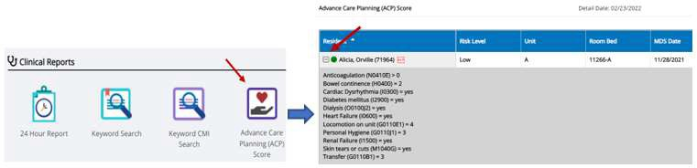

1. **CARD Score Detail Drill Down**

* To view details of any resident with the ACP notation, click on the colored dot to the left of the resident’s name > View Details > ACP > Export to PDF (if you wish to print all details of CARD Readmission).

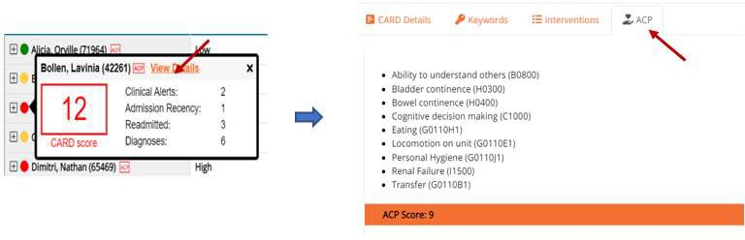

## ACP Reference Guide

**Clinical data**: Residents that have not had an initial MDS assessment completed will trigger the ACP tagging based on clinical data from several areas in the EHR, including active diagnosis, physician’s orders, and keywords.

**MDS 3.0 data:** Once a MDS is completed, a new ACPs score will be calculated from MDS 3.0 information, and the initial ACP items will no longer be used in the calculation.

## 

## Keep In Mind:

* The ACP score is a predictive tool only and may require further clinical investigation (clinical alerts, multiple QMs, keywords, etc.) for residents.
* The MDS assessments used for calculation are the most recent admission, quarterly, annual, significant change or IPA. The ACP score presents a complex view of resident status. It incorporates factors that are most relevant to residents at the end of life. This score includes measures of functional, clinical and mood status, in combination with other measures such as the presence of end stage disease, a recent decline in or unstable health status, and delirium.
* If a resident has a score of 9 or greater and a new MDS is completed which indicates the resident’s score is < 9, the resident will no longer appear on the report or have the ACP notation.
* If there is no birth date entered in the medical record, the resident will not be assigned a point for the age question.
* The advantage of knowing a resident's ACP score is beneficial. It enables providers to set families' and residents' expectations and avert the emotional decision making that often leads to inappropriate or unwanted care. Clinical staff can accurately assess the care the resident is receiving and ensure that it has an appropriate emphasis on pain management, depression management, and what is most important to the resident in supporting their quality of life.